NAME & SURNAME:ÇİSEM BAYER FERAH
MATRICULATION NUMBER: 62472203( NUMBERED 6)
Database management system implementation
PART 1
Database Setup
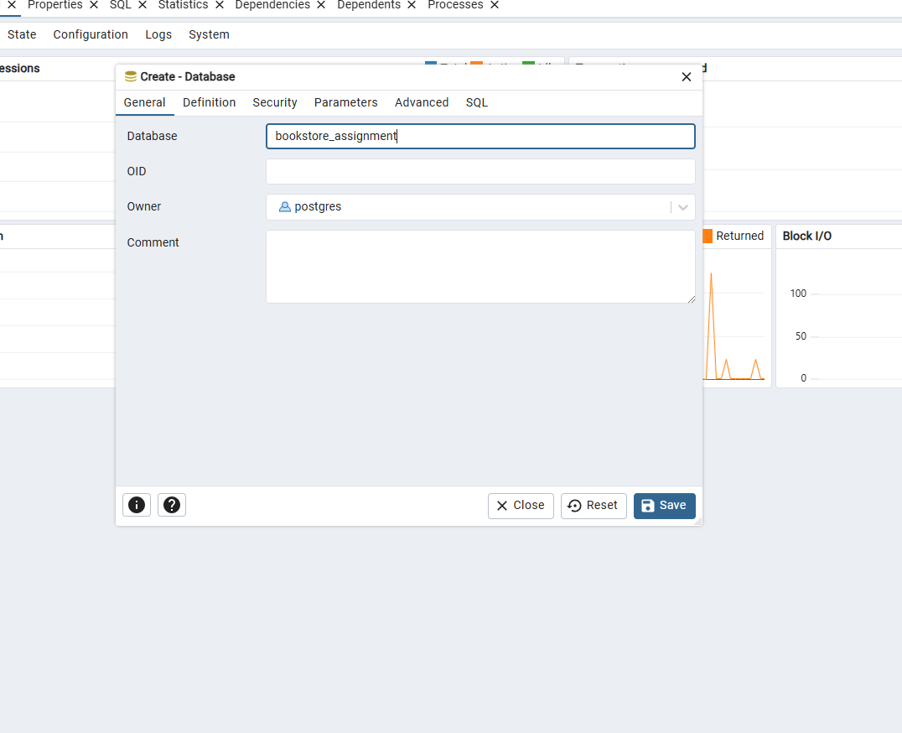
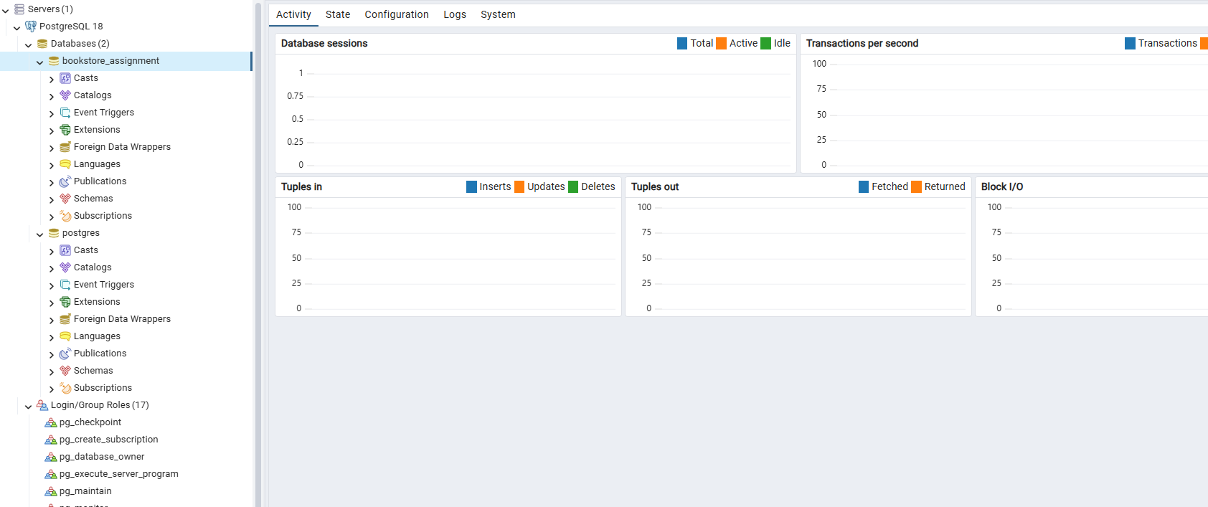

PART2 Database Implementation
Task 1) Create Tables
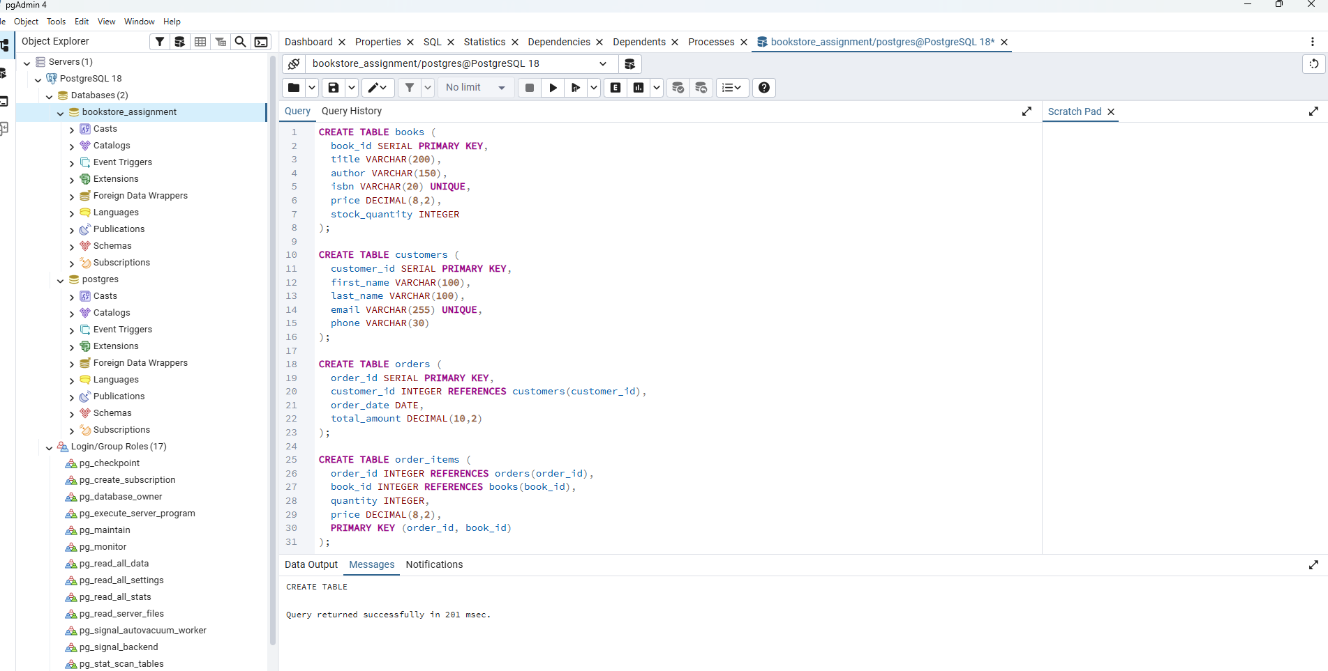
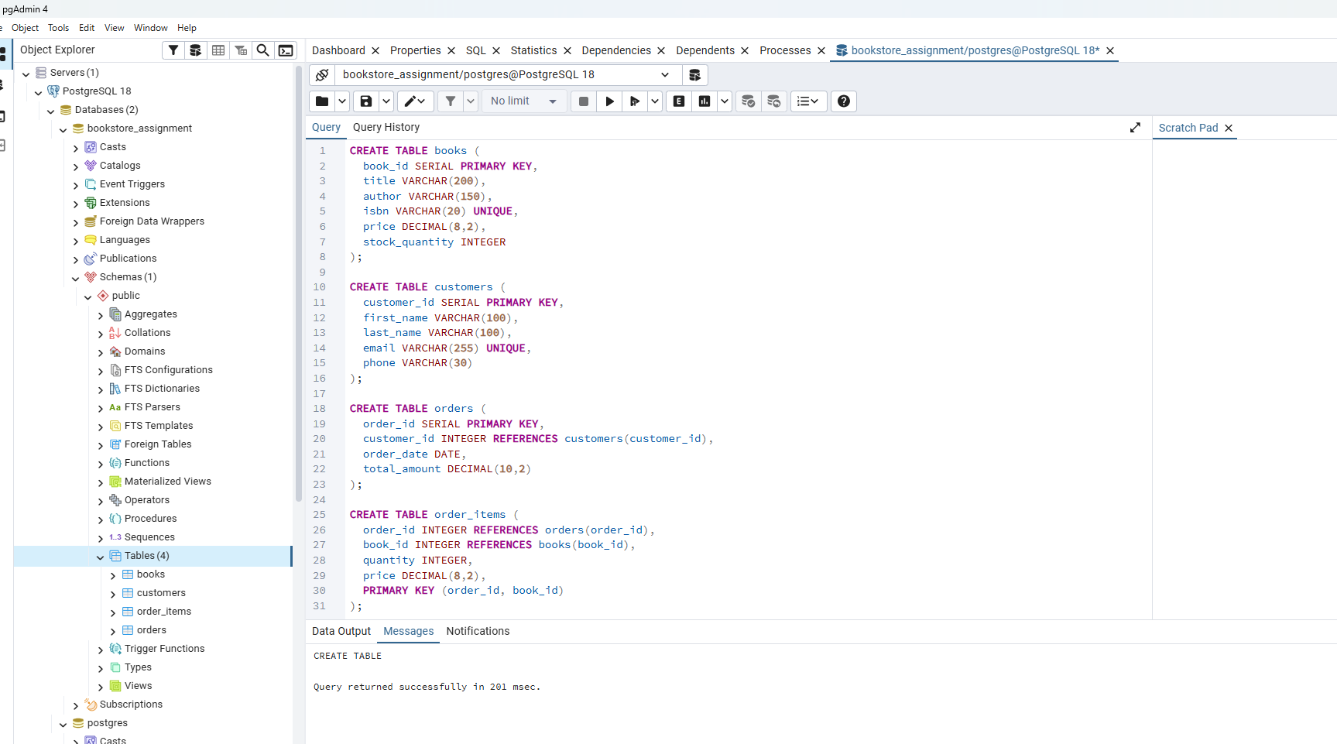
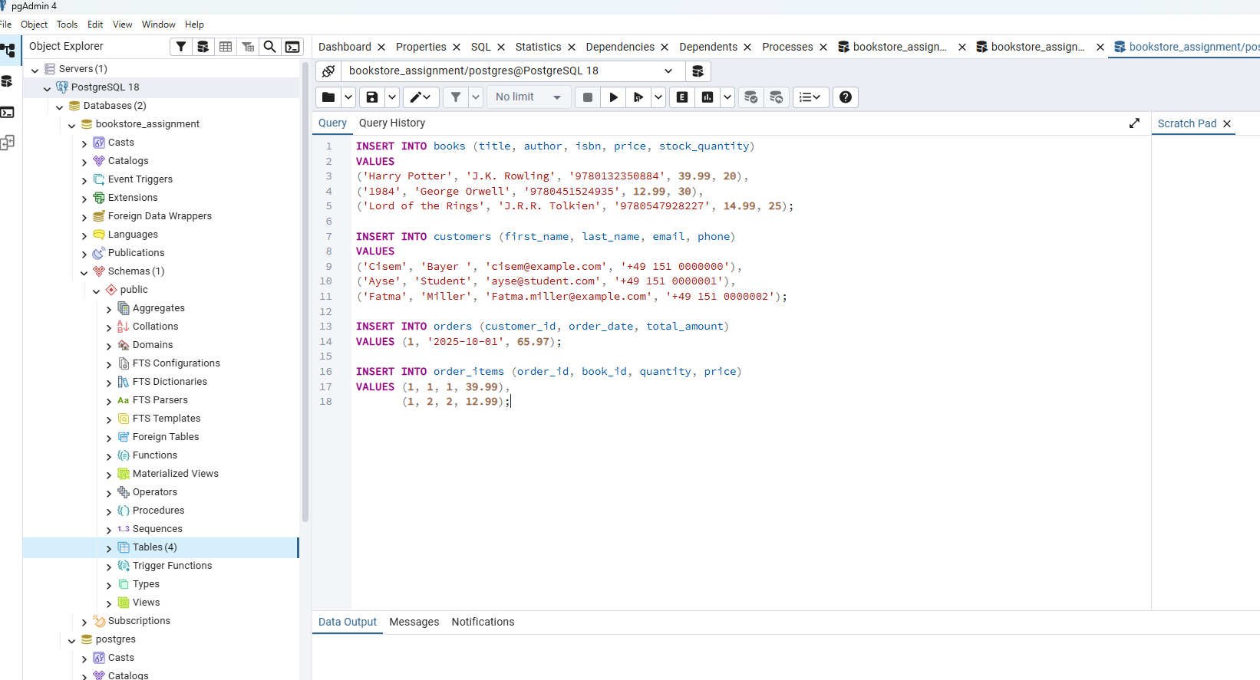
1.books (book_id, title, author, isbn, price, stock_quantity)

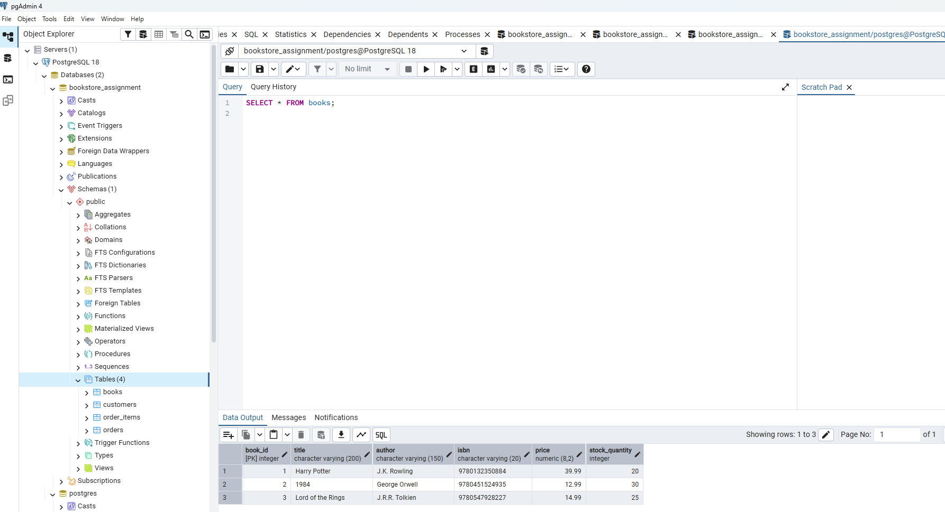
2) customers (customer_id, first_name, last_name, email, phon

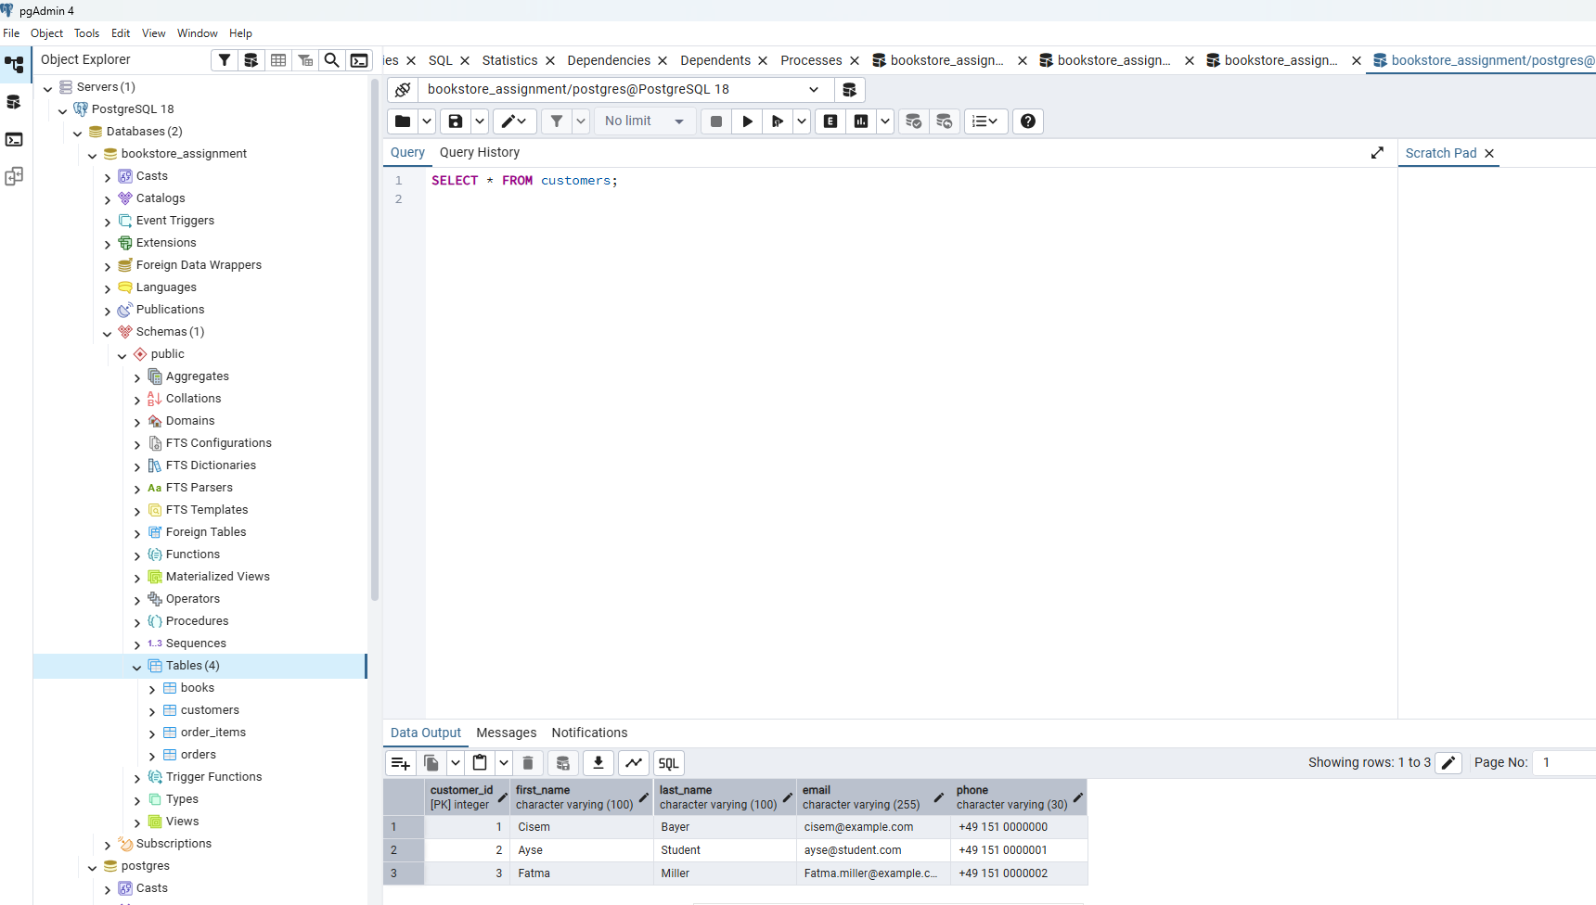
4) order_items (order_id, book_id, quantity, price)
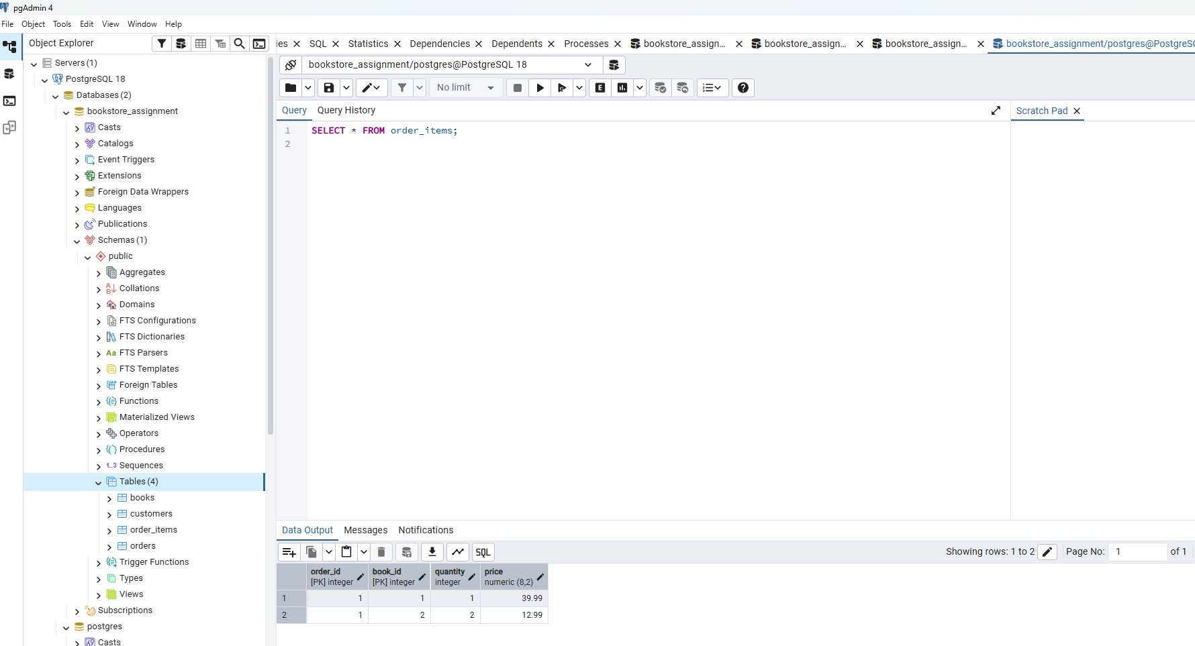

3.orders (order_id, customer_id, order_date, total_amount)

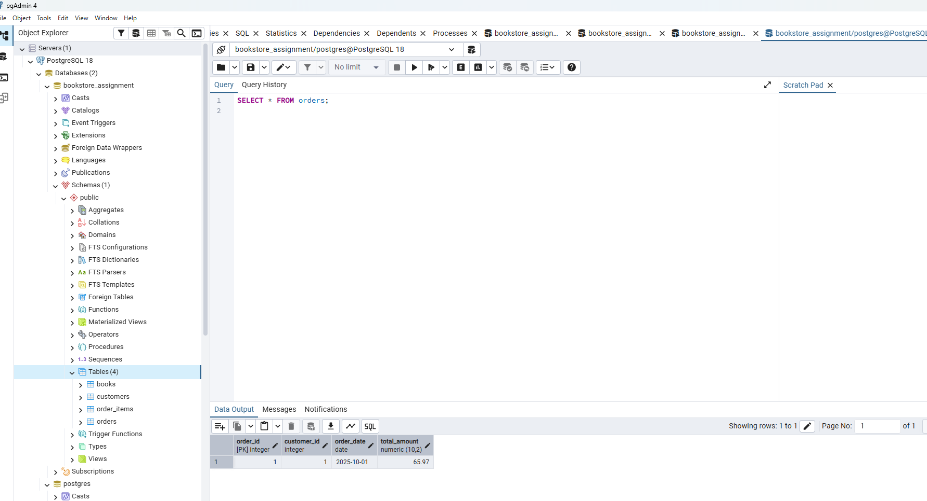
Task 2: was created with task 1
Task 3: Operational Queries
1 Show all books currently in stock

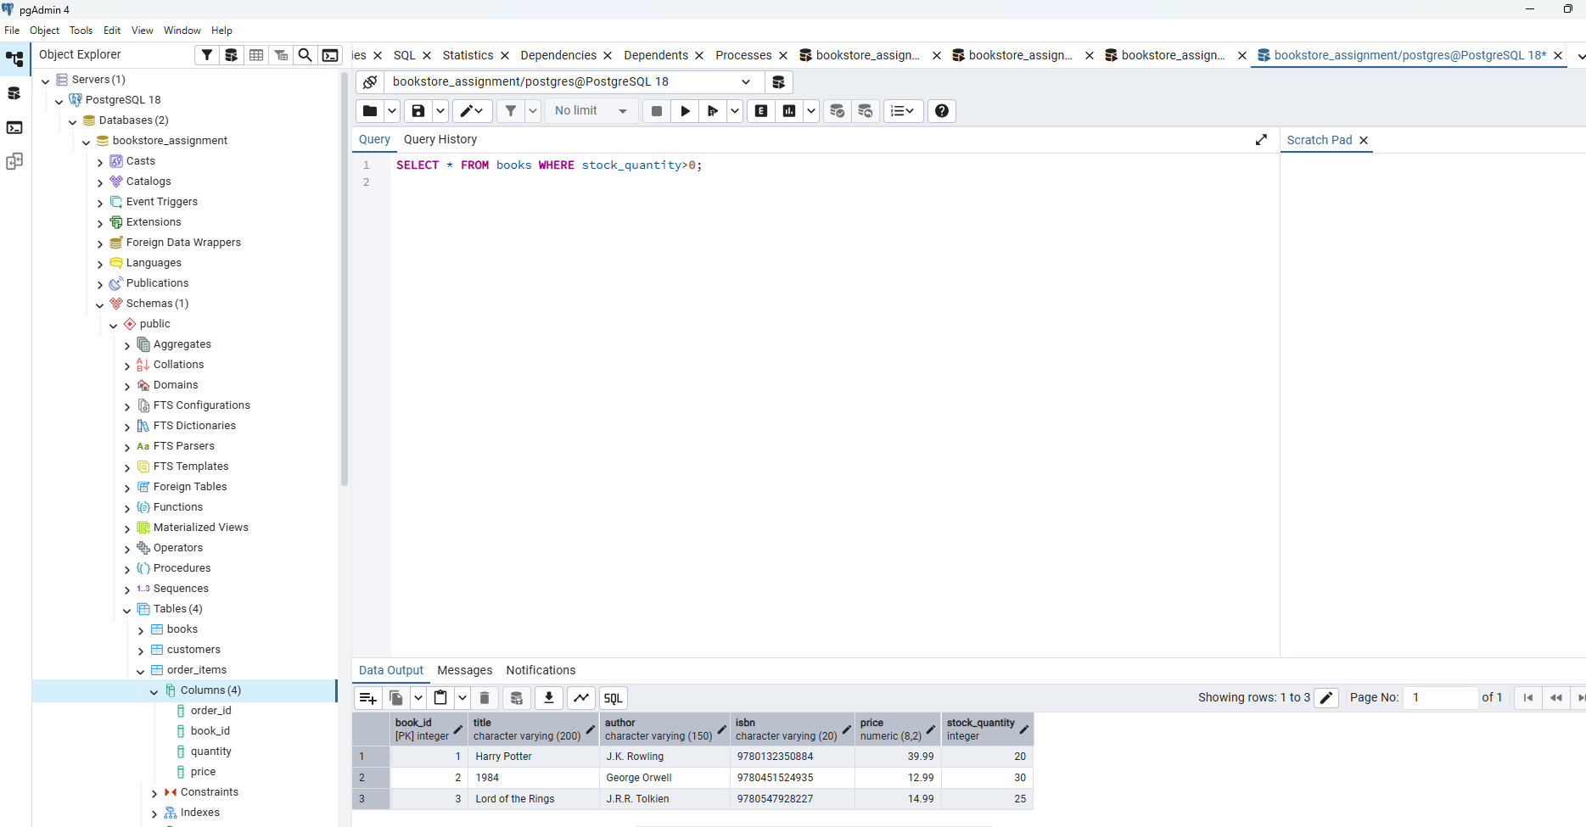
2 Find a customer by last name

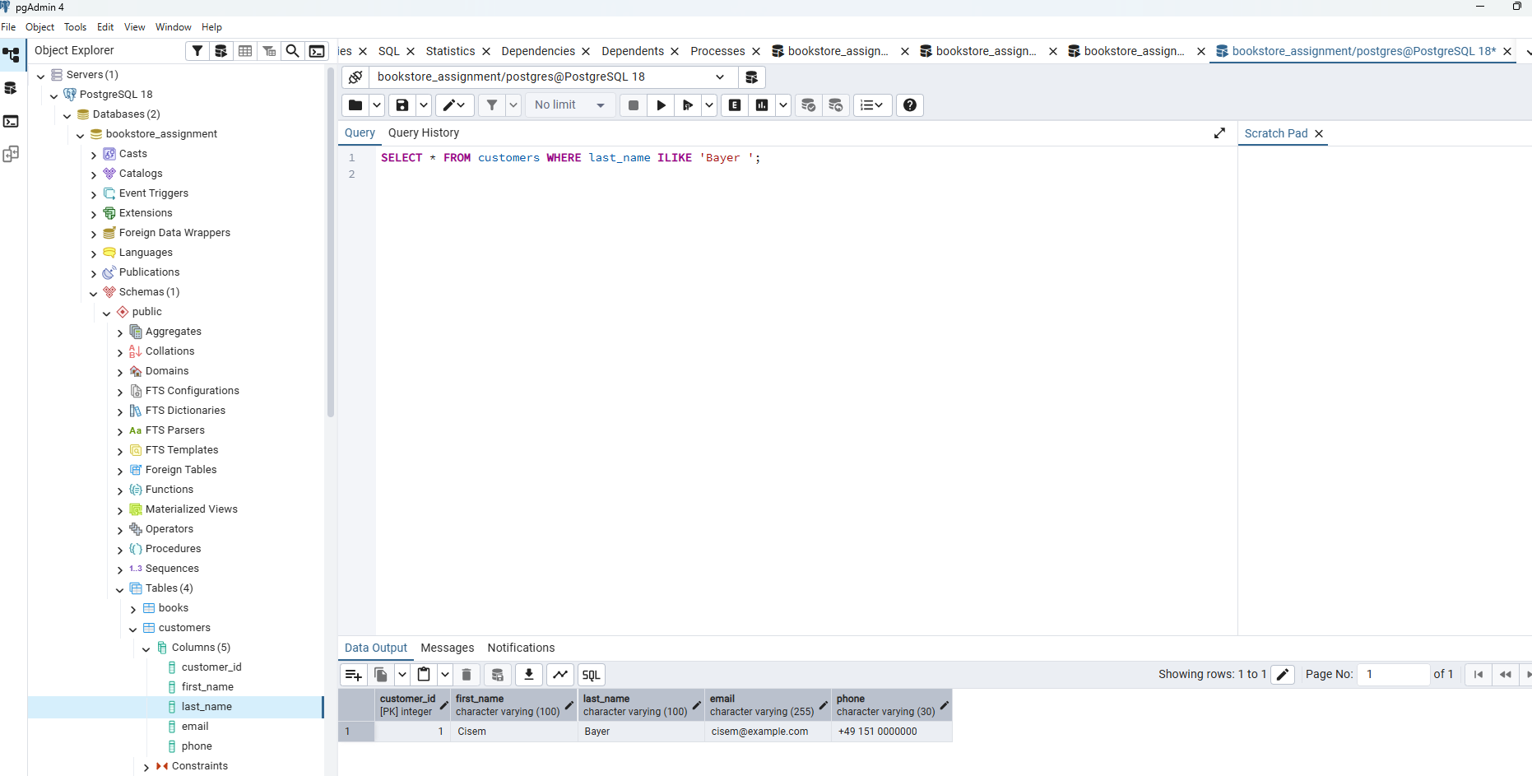
3 Calculate total sales for the current month

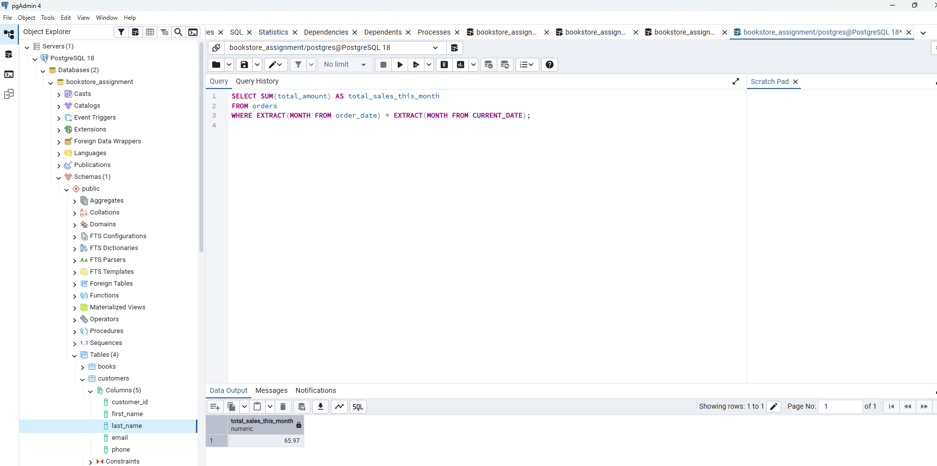
- Update stock when a book is sold

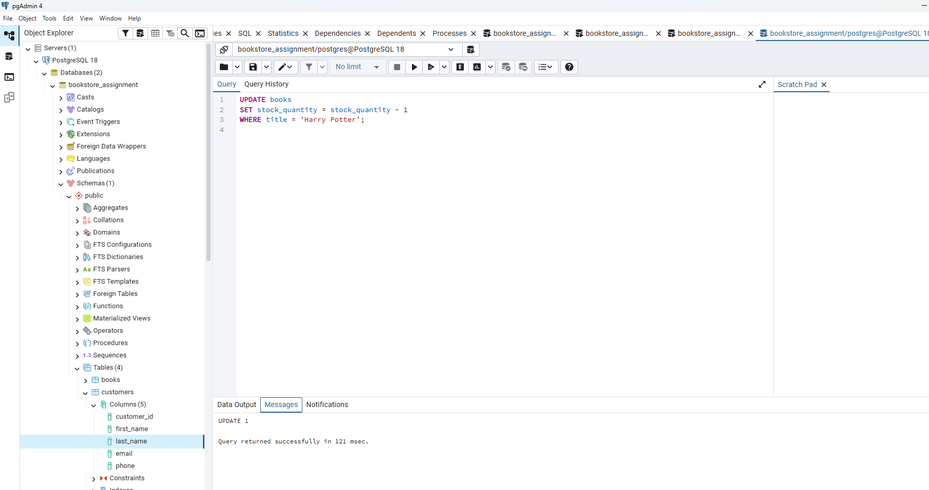
5.List all orders for a specific customer

